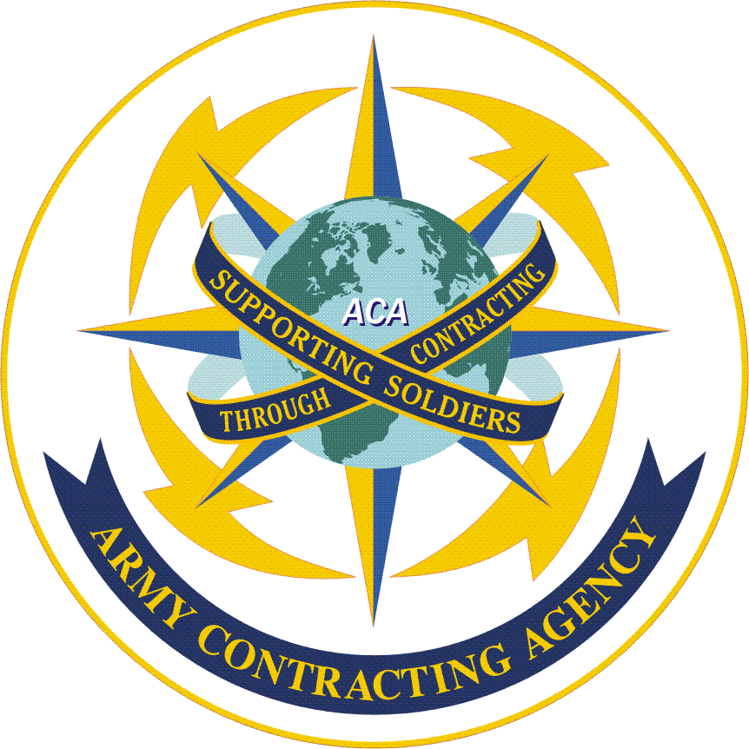

ARMY CONTRACTING AGENCY

Receiving Report Instructions

October 2004
Table of Contents

Section Page

1. Background 2

2. Receiving Report Instructions 3

3. Forms Used as Receiving Reports

a. SF Form 1449 (Commercial Item Order) 4

b. DD Form 1155 (Delivery Order or Non-Commercial Purchase Order) 4

c. DD Form 250 (Material Inspection and Receiving Report) 5

d. Invoices Used as Receiving Reports 5

e. SF Form 1034 (Public Voucher) 5

1. Background:

The Army Contracting Agency (ACA) has a worldwide mission. It includes installation support, headquarters and mission support, information management, and government purchase card (GPC) support, as well as other selected and/or locally supported items or services required by an Army activity or another Department of Defense (DoD) customer. One thing all these diverse activities have in common - they are all based on contracts that must be paid! Transactions paid by GPC are processed through the vendors' bank credit card procedures. All other payments for commercial contracts will be paid through a supporting Defense Finance & Accounting Services Office (DFAS). This guide addresses those payments processed directly by DFAS.

DFAS must have three documents to affect a contract payment: (1) a contract instrument, (2) an invoice requesting payment, and (3) a receiving report attesting to the receipt and acceptance of the supply or satisfactory completion of a service. As the Army is moving toward a paperless acquisition process, most of those required documents are (or will soon be) submitted electronically; however, whether paper or paperless the lack of one of these documents will hold up payment to the vendor. In the case of a late receiving report, the requiring activity is often responsible for payment of interest under the Prompt Payment Act.

The leading cause of interest payments has been, for many years, the lack of or improper completion of the activity "receiving report." There are many reasons for late receiving reports, however none of these reasons will "stop the clock." All will ultimately cost the activity, and thus the Army, scarce dollars in interest payments and/or vendor confidence unless more attention is given to the timely and accurate processing of these documents.

Late payments thus benefit no one – not the vendor and certainly not the Army. Because they reduce funds that can be spent to the benefit of the soldier, late vendor payments have been a continuing concern at the Army level. The subject is addressed in the Department of the Army Office of the Assistant Secretary of the Army, Acquisition Logistics and Technology, SAAL-PP memo dated December 23, 2002, which provides some proactive steps the Contracting Office can take to minimize late payments (it includes issues other than receiving reports.) To access a copy of the memo, double-click the following icon:

It should be noted that RECEIPT and ACCEPTANCE are not the same and cannot be used interchangeably. Receipt occurs when a vendor delivers goods to a specified point or individual or completes a service. Acceptance occurs when an authorized U.S. Government representative examines the goods or services, compares the goods or services to the procurement document, and is satisfied that they conform to the contract specifications. Receipt and acceptance may occur on the same day, but usually, acceptance is a few days after receipt. Keep in mind that acceptance must be accomplished within 7 days of receipt of the item or service. The activity then has up to 5 additional days to get the receiving report to the DFAS payment office. Federal Acquisition Regulations (FAR) 32.904 provides exceptions to this timeframe. Exceptions include perishable items and some construction progress payments that must be processed even more promptly after receipt of invoice. A complete description of Prompt Payment requirements is provided at FAR 32.9.

Receiving reports must be submitted based on the completion of some act, i.e. delivery of items, monthly service, percentage of completion of a repair and maintenance (construction) requirement, etc. The receiving reports should coincide with the vendors approved invoicing methods and timelines. It is noted that services such as recurring leases or services with a monthly billing also require monthly receiving reports to allow DFAS payment.

2. Receiving Report Instructions:
Receiving report regulatory requirements are provided in FAR 32.905(c) as part of the payment documentation and process.
Regulatory guidance provides, in part, that payments will be made based on receipt of a proper invoice and satisfactory contract performance. It further provides that all invoice payments, with the exception of interim payments on cost-reimbursement contracts for services, must be supported by a receiving report or any other government documentation authorizing payment (e.g., government certified voucher).
The agency receiving official should forward the receiving report or other government documentation to insure receipt by the designated payment office within 5 days after government acceptance or approval, unless other arrangements have been made.
The following instructions for completion of the receiving report requirements may be found at http://www.safaq.hq.af.mil/contracting/toolkit/rcvreports/directions.html. Complete all applicable blocks, but as a minimum, the following must be shown on the form:
- Contract number/purchase order number. Must match the contractual document or the obligating document.
- Adequate description of supplies or services to ensure identification of receipt and acceptance of goods or services ordered. For services, the description must include the period the services were rendered
- Quantities of supplies or services received or performed
- Receipt date. The date the supplies or services were received. The receipt date is the date the goods or services were delivered.
- Acceptance date. The date supplies or services were accepted. The acceptance date is the date the goods or services were inspected and determined to conform to the contract
  - Receipt and acceptance dates are separate events, but may occur on the same date. A single date can be used if it certifies both receipt and acceptance, otherwise separate dates are required. Dates must identify if it is receipt or acceptance date.
  - Constructive acceptance. Constructive acceptance applies if the acceptance date is more than 7 calendar days after date of receipt, unless the contract provides a longer acceptance period. Enter the constructive acceptance date in the Integrated Accounts Payable System (IAPS) as the acceptance date if constructive acceptance applies. Ensure that a written explanation of the method used to determine the acceptance date is annotated on/attached to the receiving report.
- Total dollar amount. Although not required by the FAR, dollar amount may be required for partial receipts and to the appropriate appropriation.
- Signature or approved electronic equivalent of government official authorized to accept supplies and services.
- Printed name, mailing address, and telephone number of designated government official accepting goods or services. Mailing address may be a commercial or organizational address. The state and zip code are required for organizational addresses. The telephone number may be a DSN or commercial number. An extension is not acceptable.
The following additional information/clarification is required to be included in receiving reports:
- The vendor name and address must be shown and COMPLETE contract number.

Examples: DABJXX-02-P-9999
DABJXX-02-D-9999-0001
DABJXX-02-C-9999 CALL # F123

- Description by contract line item number (CLIN) and quantities of supplies delivered or services performed.

- The date supplies were delivered or services were performed as the "received date." Not the date you decided to sign.

- The date the merchandise or services were accepted. Not the date you decided to sign.

- Once the receiving report has been completed, transmit the document to the designated DFAS for payment or to the supporting GPC holder if within his/her monetary authority. If using a paper form, we recommend you use a transmittal document, sequentially numbered for tracking purposes. Fax copies may be accepted by some DFAS locations, however, check to ensure they will accept that method. Do not fax and mail the same document unless so directed by DFAS.
3. Forms Used as Receiving Reports
a. Standard Form 1449 (Commercial item order)
- Complete receiving report using a copy of the actual commercial order (SF 1449).

- Ensure completion of blocks 32a (check received/accepted blocks); 32b (signature of official authorized to accept supplies/services); 32c (date supplies/services accepted); 32d (printed name and title of authorized representative); 32e (mailing address of authorized representative); 32f (telephone number); block 32g (E-mail address); 33 (shipment number); 35 (amount verified correct); 36 (payment - complete, partial or final); 42a (printed name of receiver); and 42c (date received). The same name may appear in blocks 32a or 32b and 42a if the same individual both receives and accepts the supplies or services. If there is a separate "receiver," their name must appear. No signature is required in Block 42a.

- If partial payment is authorized, annotate number of items or amount of services that have been received and accepted, as well as total dollars per line item to be paid, by lining through the totals and writing in the new amount in ink. Then circle the change and initial. The lining through should not obliterate the figure - but clearly show that the total, for purposes of the partial payment, is a different figure than reflected on the original order.
b. DD Form 1155 (Delivery Order or non-commercial Purchase Order)
- Complete receiving report using a copy of the actual delivery order or purchase order (DD Form 1155).

- Complete Block 26 with a signature, printed name, telephone number and title of a government official authorized to receive and accept the item or service (also check corresponding blocks for receipt and acceptance); block 27 (check partial or final); 38 (received by) and; 39 (date of receipt). Block 26 and 38 may be the same person if the individual received and accepted the supplies or services. If a second individual actually noted the receipt of the supplies or services; that individuals name and date of receipt shall be placed in blocks 38 and 26.

- See instructions for partial payment for SF 1449 above - use same procedures.

c. DD Form 250 (Material Inspection and Receiving Report)

- The contractor may submit this form as an invoice. In that event, the receiving/acceptance activity will complete: Blocks 21 a or b and 22 including signatures, typed names, titles, mailing address, and phone numbers. There may be a separate receiving official and acceptance official so Block 21 and 22 may reflect the same individual or a different individual. In either case, no signature is required in Block 22.

- If an invoice has been completed separately by the vendor, complete DD Form 250 including blocks 1 through 20 as well as 21 a or b and 22.

- The following icon provides a DD 250 Form that may be electronically completed for your convenience. Click twice to open.
d. Invoices Used As Receiving Reports
- A vendor's invoice can be used as a receiving report if the contract/purchase order provides for use of Government Certified Invoices instead of a separate receiving report. The invoice must be date stamped upon receipt by the office indicated in the contract to receive the invoice. In addition, the stamp must identify that office (i.e. not merely be a date stamp).

- If you are accepting vendor performance or delivery by using a Government Certified Invoice include the statement: "I certify that the goods/services have been received and accepted on (day, month, and year)." This statement may be on an invoice, delivery ticket, voucher, or separate piece of paper and must contain printed name, title, telephone number, date, and signature of the government official authorized to receive and accept the supplies or services.
e. SF 1034 (Public Voucher)
- If the SF 1034 is used as a receiving report, assure that the specific information identified in FAR 32.905(b) is included on the voucher. In addition, assure all appropriate blocks are completed. Note: DODIG Audit 2002-056 discourages the use of a SF 1034 for payment of contracts and emphasizes that, if used, it must include the receipt and acceptance dates.

